- We forecast that UK CPI inflation will average 2.8% in 2025, unchanged from last month. The fading drag from falling energy prices, a strong dollar, and recent fiscal policy changes will all put upward pressure on inflation in 2025.
- November's increase in the CPI rate to 2.6%, from 2.3% in October, was largely as expected. Base effects were the main driver of November's rise, after both core goods and fuel prices were unusually weak in November 2023. These base effects are likely to persist in the near-term, pushing inflation close to 3% by January.
CPI inflation rose to 2.6% in November, from 2.3% in October. The rise was largely down to a base effect from a weak core goods reading in November 2023, and a smaller drag from the petrol category, with a modest rise in pump prices between November and December this year contrasting with a large fall between those months in 2023. Services inflation was unchanged at 5% in November. Meanwhile, RPI and RPIX inflation rose by 0.2ppts between October and November to reach 3.6% and 3%.
We continue to expect inflation to rise further around the turn of the year, as more base effects caused by weakness in core goods and fuel prices last winter come into play.
Further out, our forecast is little changed compared with last month, with CPI inflation forecast to average 2.8% in 2025. The drag from falling energy prices has begun to recede and will disappear altogether from the spring. Base effects in the core goods category will be compounded by the impact of a strong dollar, which will increase the price of imported goods. We expect softening pay growth and smaller increases for regulated and indexed prices to reduce some of the momentum behind services inflation in 2025. But there will be some mitigation from the impact of recent fiscal policy announcements. Firms are likely to pass on some of the rise in costs caused by the increase in employers' national insurance contributions, while the imposition of VAT on private school fees will also exert modest upward pressure on inflation in 2025.
Chart 1: We expect inflation will continue to edge up and average close to 3% in 2025
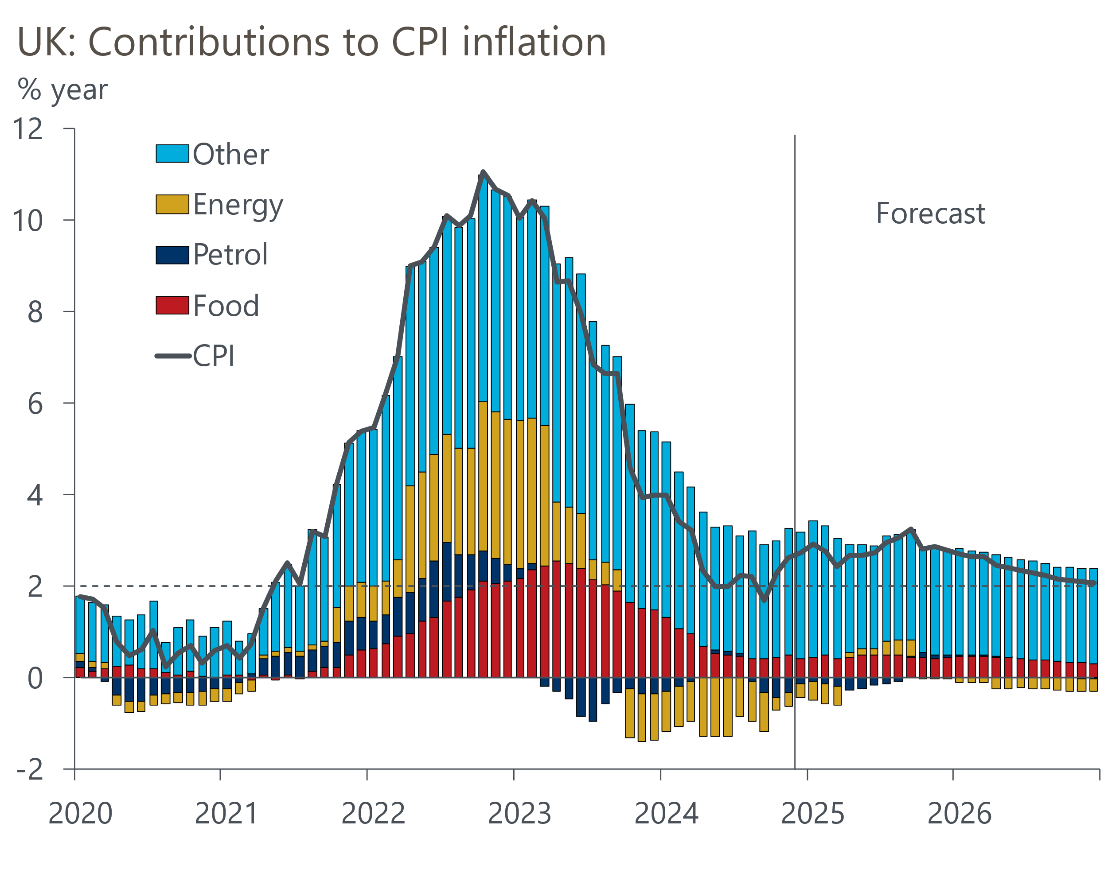
Source: Oxford Economics, Haver Analytics

